

Boardwalk Fire Pit Table Installation Instructions

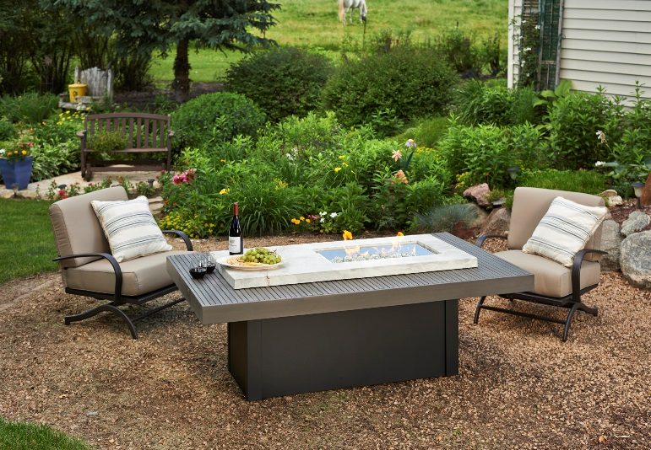

Contents

Required Tools……………..……..3

Placing the Table…………………5

Gas Connection…….…………….6

Igniter Installation (pt 1)……….....7

Fire Pit Assembly….……….……..8

Igniter Installation (pt 2) …….….10

Locating Propane tank………….11

Care and [maintenance](https://www.google.com/search?safe=off&espv=2&q=maintenance&spell=1&sa=X&ei=6YYIVJ3pPMX4yQPw5IKgCw&ved=0CBoQvwUoAA) ………...11

**Notice:**

This unit is listed for use in North America for both residential and commercial applications. In the event that the appliance can be used by those unfamiliar with the appliance, we suggest the use of a master Key Valve to prevent unauthorized use. The use of a Glass Guard is also strongly recommended when small children or other individuals with reduced sensory or mental capacities may be in close proximity to the appliance.

42444:A 9.4.2014

Required Tools

* **Utility Knife**

To cut and remove packaging

* **2 Open Ended Wrenches**

To make gas connections

* **Leather Gloves**

To protect hands from rough edges found on the coffee table.

* **One (1) AAA Battery (not included)**

Required for igniter installation

* **Battery or electric power drill with Phillips tip**

Used for attaching the composite top to fire pit base

**C:\Users\Tony\AppData\Local\Microsoft\Windows\Temporary Internet Files\Content.IE5\6M7MRM98\MC900383642[1].wmf**

* **It is required that a minimum of two people assemble and install the Boardwalk. The concrete section of this fire pit table may require more people to help lift.**

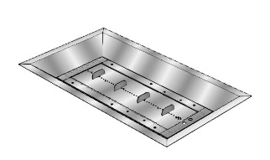Included with your fire pit:

* CF-1224 Burner kit

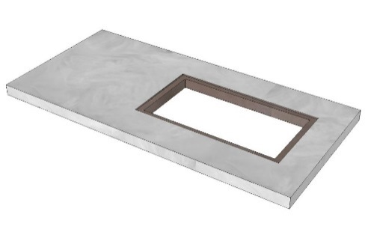

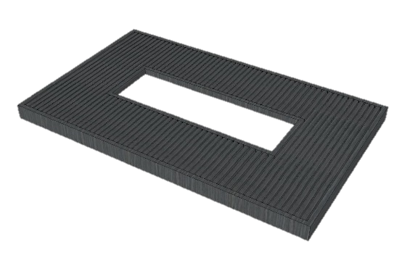

* Composite wood and SuperCast concrete tops

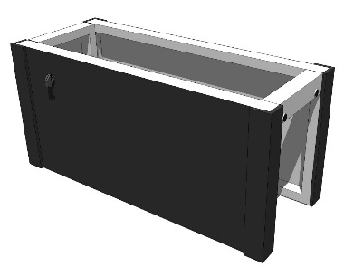

* Metal Fire Pit Base

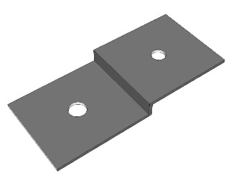

* Top Bracket (X4)

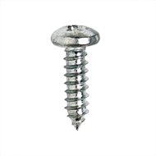

* Sheet Metal Screw (x8)

Placing the Fire Pit table

**1.** Remove access door

**2.** Remove the base from the box

**3.** Move the base without door to desired location and set into place on a hard flat surface. This fire pit has rubber feet on the bottom which allow for proper ventilation of the fire pit. Placing this fire pit on grass or similar surfaces may block airflow and increase the chance of injury in the event of a gas leak.

**4.** When locating your coffee table, refer to the Crystal Fire manual and maintain clearance to combustibles.

Sierra fire pit table shown, finishes and styles may vary

*Before completing the following steps, read and understand the Crystal Fire owner’s manual.*

Gas Connection

Connect the incoming black rubber gas hose (for propane) or incoming natural gas line to the valve. It is not recommended to use Teflon tape or pipe dope on the connection to the valve with flare fittings.

* LP installations use the hose and regulator provided with the burner.
* Natural Gas installations refer to the supplied Crystal Fire Manual.

**Use two wrenches to fully tighten gas connections.**

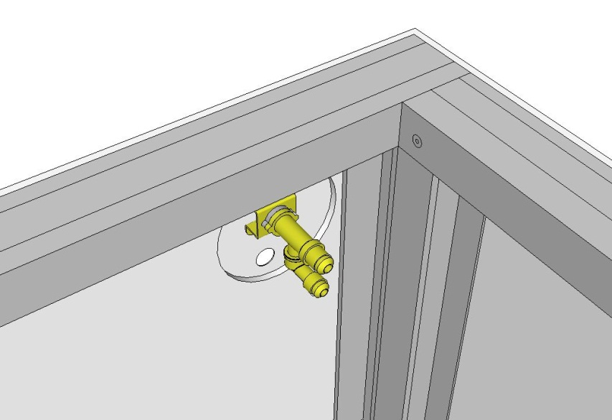

Gas line to burner (included metal flex hose)

Attach incoming gas here (black rubber propane hose or incoming natural gas line)

**Do not make gas connections to burner until concrete top is installed. Gas connections can be made from below or from above by lifting burner to access gas line. TIGHTEN ALL FITTINGS WITH TWO WRENCHES AND CHECK FOR LEAKS BEFORE OPERATION**

Igniter Installation (Part 1)

*Note: Before installing ignition system, ensure that gas valves are closed and gas is disconnected for safety.*

1. Make sure the valve is in the OFF position

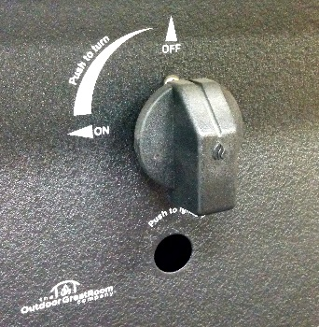

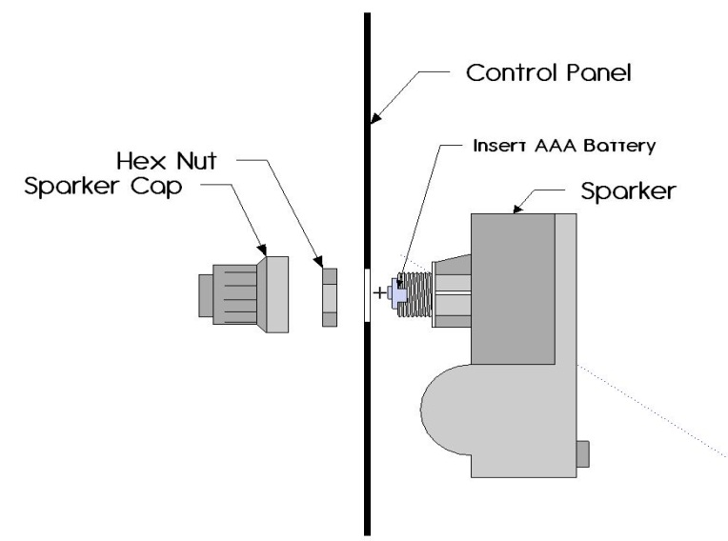

Insert AAA Battery with positive side facing outward

1. Unscrew sparker cap and hex nut (sparker included with burner). Install as shown below.

Assembling the Boardwalk

1. With the help of at least one other person, remove concrete and composite wood tops from packaging and set on a soft surface. With the base in its final position, set the composite wood top on top and center the opening on the metal fire pit base.

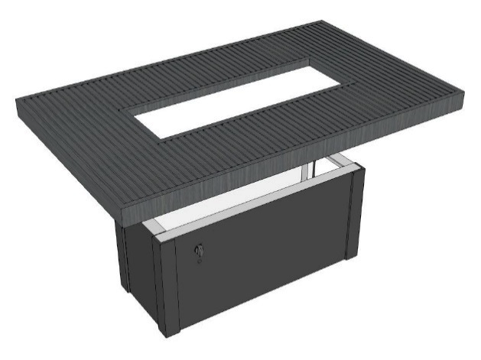

2. Place a bracket 12” from each corner on the long sides of the composite wood top and attach the brackets with the included sheet metal screws.

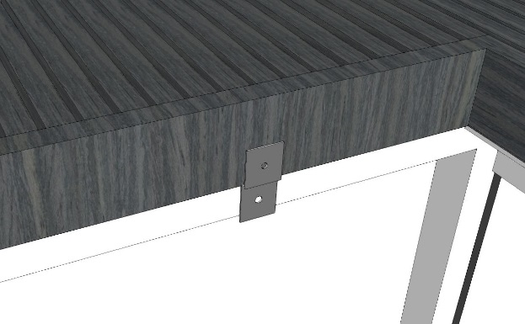

12” from end

8 5/8”

3. Before placing the concrete top, see the diagram below and mark out corner locations of the concrete with masking tape or a pencil.

8 5/8”

9”

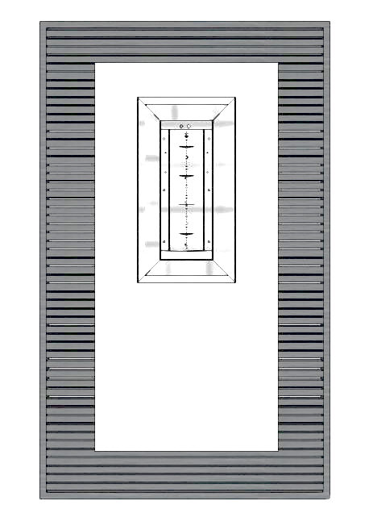

Control panel

9”

4. With at least one other person, carefully set the concrete top on to the base, being careful not to scratch the composite wood top.

5. Set the burner into the opening in the concrete top and proceed with hooking up the igniter and gas lines (See your crystal fire burner instruction manual for full gas hookup information)

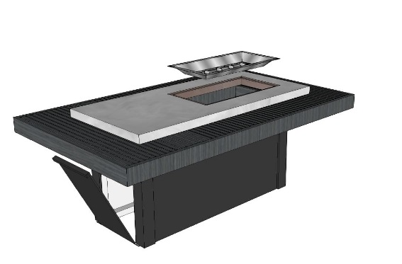

Control panel

Locate sparker at this end

Igniter Installation (Part 2)

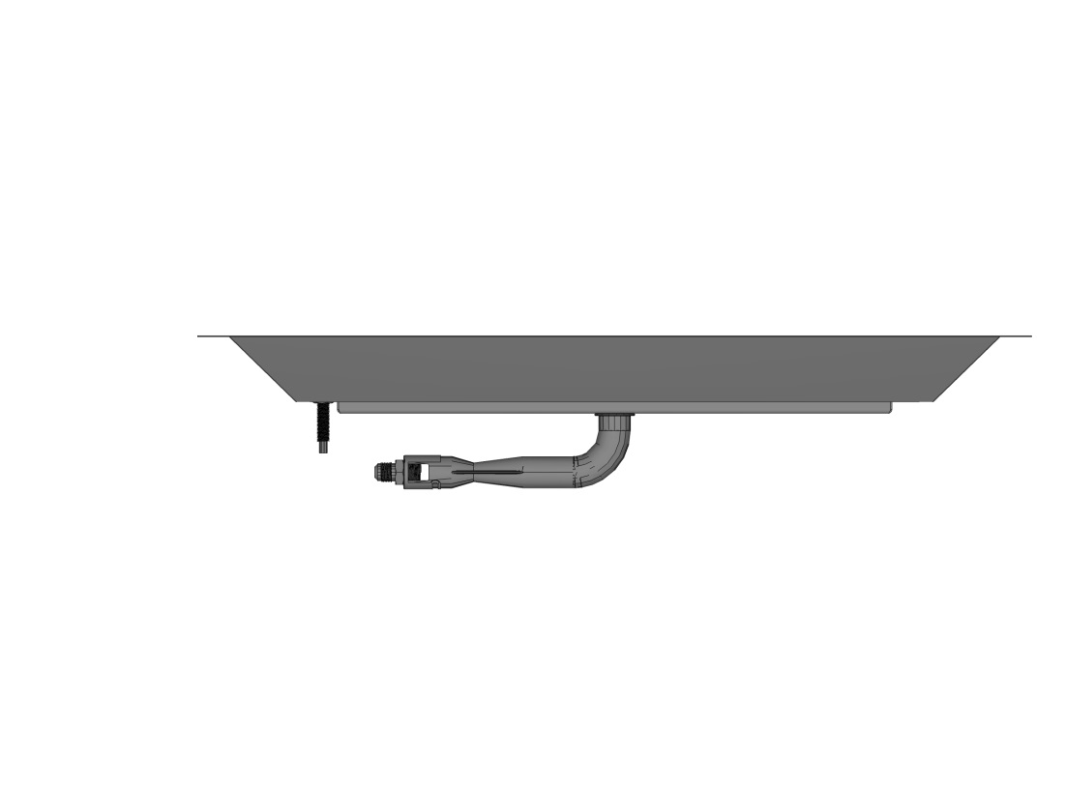

Ignition

Ground

1. To properly install ignition system, an Ignition and Ground wire need to be attached to the igniter box.

* Start by plugging the black Ignition wire hanging from the burner in to one side of the back of the igniter (either side is fine).
* Next; plug the Ground wire into the open port on the igniter box.
* Test system by depressing the button on the igniter. A continuous repeating spark at the igniter on the burner means everything is connected properly. Consult the troubleshooting section of your crystal fire owner’s manual if spark is weak, intermittent, or not present.

1. Once the system is grounded and igniter operation is verified, gas hookups can be performed by a qualified gas installer.

**IMPORTANT**

Please consult your Crystal Fire instruction manual for detailed instructions and important information related to hooking up your burner, including safety information, proper tightening of connections with two wrenches and full burner setup and lighting instructions.

**DO NOT ATTEMPT TO INSTALL BURNER WITHOUT FIRST CONSULTING THE MANUAL. IF YOU ARE UNSURE OF HOW TO COMPLETE THE STEPS OUTLINED, CONSULT A QUALIFIED TECHNICIAN**

Locating your Tank

1. Your tank should be positioned so that the fuel can be shut off after each use.
2. Slide the tank into fire pit base, past the threshold of the door opening. Ensure the door can close completely with the tank installed.
3. Confirm all hoses are clear and not touching the burner.

**WARNING**

After consulting the manual and following instructions, remember; before operating, all gas connections must be fully checked for leaks

Care and Maintenance

* If scratches occur in the composite wood top, they can be easily sanded out with fine grit sandpaper just as you would with a real wood surface. Sanding lightly with the grain will remove most light scratches that may occur.
* Table should be covered when not in use. Prolonged exposure to moisture may cause discoloration of surfaces , so ensure the table is dry before covering.
* We recommend cleaning and sealing your concrete Supercast top as often as necessary. If the top beings looking dull; clean and re-seal with commercially available concrete cleaner and acrylic sealer. See the Supercast care and maintenance sheet included with your concrete top for more information.

ENTIONALLY LEFT AWESOME.



**Warranty:** Fire pit tables are covered under a 1-year manufacturer’s warranty. Please visit <http://www.outdoorrooms.com/warranty-form> to register your product.

2015 Silver Bell Road • Suite 195 • Eagan, MN 55122

**Toll Free: 1-866-303-4028 •** [**Sales@OutdoorRooms.com**](mailto:Sales@OutdoorRooms.com)